 COMSATS University Islamabad, Lahore

FALL 2020
□ Sessional-1 □ Sessional-II □ Terminal Examination
Course Title: | Semantic Web (Lab) |  |  |  | Course Code: |  | CSE344 | Credit Hours: | 3(2,1)
Course Instructor/s: | Sana Rizwan |  |  |  | Program Name: |  | BSSE
Semester: | 7th | Batch: | FA17 | Section: | A/B/C |  | Date:
Time Allowed: | 2.5 Hours + 30 mins(submission) |  |  |  | Maximum Marks: |  |  | 50
Student’s Name: |  |  |  |  | Reg. No.
Important Instructions / Guidelines:
- Rewriting and cuttings are not allowed. All questions are compulsory.
- Coding should be in proper syntax.
- Prefixes and namespaces should include.
- Section III-- Build ontology in Protégé and Take snapshot all of them in sequence, paste it in MS Word file with your name and registration number. You have to submit it in google classroom against specific assigned task.

Question: (Marks 3+4+4+2+2+5+9+5+16= 50)

Write short answers.

1. Write XML code that carries information about a “book” having name, author, language and genre.
________________________________________________________________________________________________________________________________________________________________________________________________________________________________________________________________________________________________________________________________________________________________________________________________________________________________________________________________________________________________________________________
2. Write the XML DTD coding structure with DTD internal binding about “Beginnersbook” with to, from, subject and message information included in it.
________________________________________________________________________________________________________________________________________________________________________________________________________________________________________________________________________________________________________________________________________________________________________________________________________________________________________________________________________________________________________________________
3. Write the XML Schema coding structure about “Beginnersbook” with to, from, subject and message information included in sequence with complexType structuring.
________________________________________________________________________________________________________________________________________________________________________________________________________________________________________________________________________________________________________________________________________________________________________________________________________________________________________________________________________________________________________________________
4. Identify XML code having brand and category are the attributes associated with element car with description of name and horsepower.
________________________________________________________________________________________________________________________________________________________________________________________________________________________________________________________________________________________________________________________________________________________________________________________________________________________________________________________________________________________________________________________
5. Write XSD code describing enumeration 2,4,6 about “SmallDressSize” as SimpleType restriction.
________________________________________________________________________________________________________________________________________________________________________________________________________________________________________________________________________________________________________________________________________________________________________________________________________________________________________________________________________________________________________________________
6. Write RDF code for the given graph;

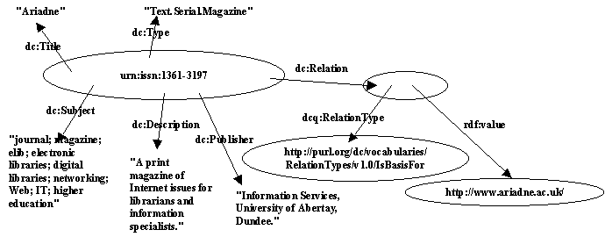

________________________________________________________________________________________________________________________________________________________________________________________________________________________________________________________________________________________________________________________________________________________________________________________________________________________________________________________________________________________________________________________
________________________________________________________________________________________________________________________________________________________________________________________________________________________________________________________________________________________________________________________________________________________________________________________________________________________________________________________________________________________________________________________

7. Write the code in RDF with its complete schema structure. State the code in proper syntax.

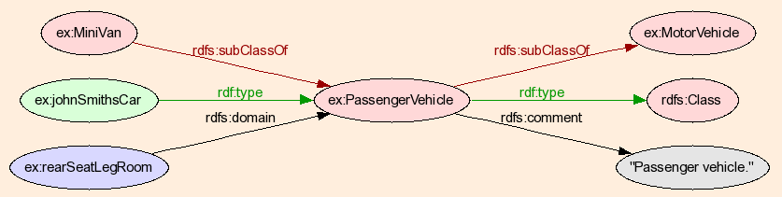

________________________________________________________________________________________________________________________________________________________________________________________________________________________________________________________________________________________________________________________________________________________________________________________________________________________________________________________________________________________________________________________
________________________________________________________________________________________________________________________________________________________________________________________________________________________________________________________________________________________________________________________________________________________________________________________________________________________________________________________________________________________________________________________

8. This HTML file is displayed on the browser, write down RDFa coding document related to it.

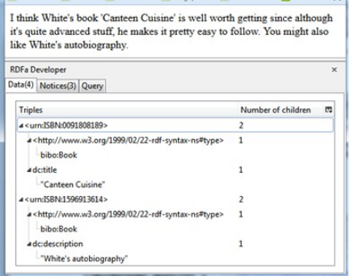

9. Using Protégé (Build ontology in Protégé and Take snapshot all of them in sequence, paste it in MS Word file with your name and registration number)

Case Study:

“Africian_Wildlife” ontology will generate with animal, plant and plantpart are the sub-classes with variants in it.

- Make an ontology having following classification;
- Create class/ subclasses
- Create individuals
- Object type properties
- Data type properties
- Range and domain
- Annotations/ Assertions

- Write SPARQL query and get results from the above-mentioned ontology.
- Get Individuals
- Get Classes
- Get any string object from annotations/ assertions

BEST OF LUCK

